**Project Design Phase**

**Solution Architecture**

|  |  |
| --- | --- |
| Date | 14 June 2025 |
| Team ID | LTVIP2025TMID59165 |
| Project Name | Citizen AI – Intelligent Citizen Engagement Platform |
| Maximum Marks | 4 Marks |

**Solution Architecture:**

Solution architecture is a complex process – with many sub-processes – that bridges the gap between business problems and technology solutions. Its goals are to:

* Find the best tech solution to solve existing business problems.
* Describe the structure, characteristics, behavior, and other aspects of the software to project stakeholders.
* Define features, development phases, and solution requirements.
* Provide specifications according to which the solution is defined, managed, and delivered.

**Example - Solution Architecture Diagram:**

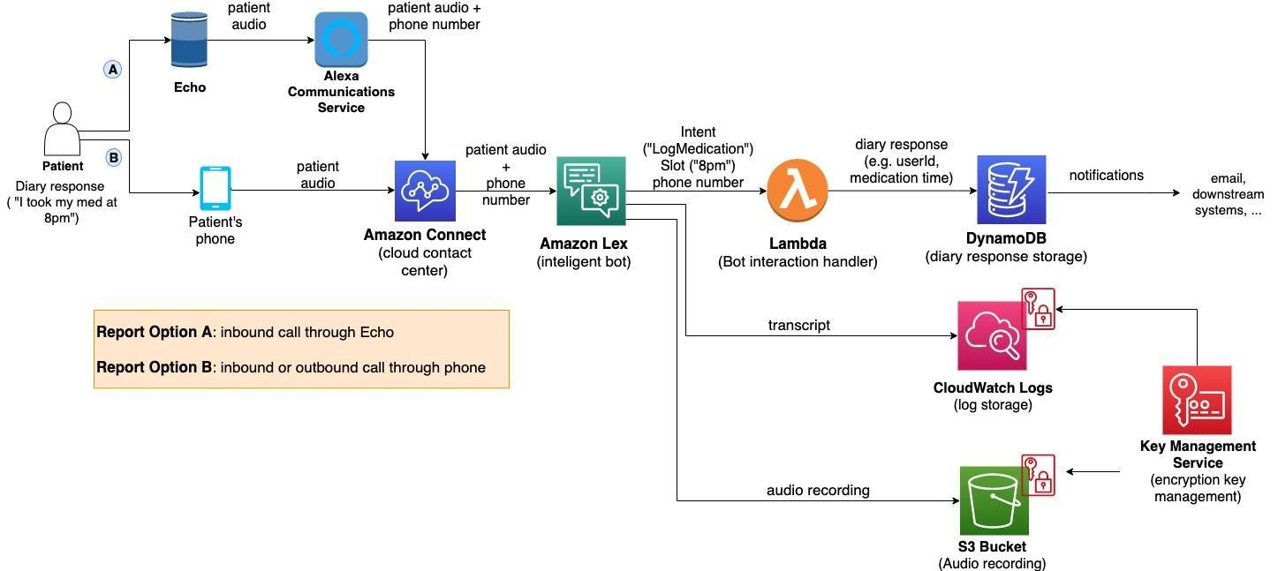

*Figure 1: Architecture and data flow of the voice patient diary sample application*

**Template for Architecture & Design Documentation**

**1. Title**

Voice Applications in Clinical Research Powered by AI on AWS – Architecture and Design Considerations

**2. Authors & Date**

Clarence Choi and Angela Wang  
Published: April 12, 2021

**3. Domain/Industry**

Healthcare, Clinical Research, AI-powered Contact Centers

**4. Problem Statement**

Traditional data collection methods in clinical trials (e.g., paper diaries, mobile apps) are often ineffective for patients with impairments or literacy challenges. There is a need for a more inclusive, hands-free, and voice-driven patient outcome reporting solution.

**5. Objective**

Develop a secure, accessible, voice-based application for collecting electronic clinical outcome assessments (eCOAs), particularly electronic patient-reported outcomes (ePROs) and eDiaries, using AWS AI services.

**6. Solution Architecture Overview**

* **Patient Entry Points:**
  + Inbound call via smartphone/landline
  + Inbound call via smart speaker (e.g., Amazon Echo)
  + Outbound call via Amazon Connect API (optional)
* **Core Services:**
  + **Amazon Connect** – Handles voice interactions, call routing
  + **Amazon Lex** – Conversational AI for symptom/question interpretation
  + **AWS Lambda** – Custom business logic (e.g., database write, notifications)
  + **Amazon DynamoDB** – Storage of patient responses
  + **Amazon Pinpoint** – Sends alerts/notifications to caregivers or investigators

**7. Key Features**

* Hands-free, conversational patient interface
* Natural language understanding for open-ended symptom reporting
* Authentication using ANI (caller ID) + voice security questions
* Error handling with fallback intent logic
* Auditability via conversation logs and traceable data flow
* HIPAA-compliant data handling with encryption and obfuscation

**8. Voice User Interface (VUI) Considerations**

* Avoid GUI-style list conversion to voice
* Enable open-ended symptom expression (e.g., “I have a headache”)
* Use fallback intents for unknown responses
* Store unknown responses with flags for post-review

**9. Security & Compliance**

* Compliance with **FDA 21 CFR Part 11**, **HIPAA**, **HITRUST**, **SOC**
* Use of **KMS encryption**, **Lex slot obfuscation**, **CloudWatch**, and **CloudTrail**
* Protect PII/PHI through minimal exposure and encryption
* Clear text removal in Amazon Connect by setting empty contact attributes

**10. Benefits**

* Greater inclusivity in clinical trials
* Improved data accuracy and patient adherence
* Scalable and reusable architecture
* Faster innovation with AWS prototyping support

**11. Tags**

#Healthcare #AI #AWS #ClinicalTrials #VoiceTechnology #AmazonLex #AmazonConnect #PatientEngagement #HIPAA

**12. Further Reading**

* [AWS for Healthcare & Life Sciences](https://aws.amazon.com/health)
* Part 2 of this blog series (implementation guide)